MY APP

**Calculator App**

**What is is about :** my app is about to app that how can not find there answer and also want a calcutor and ask any math question in this app there are going to be 3 screen Calculator screen , answer screen and post over question screen

**Screens:Login Screen: this is for login there are 2 potions write your slef or just click on sing in with google**

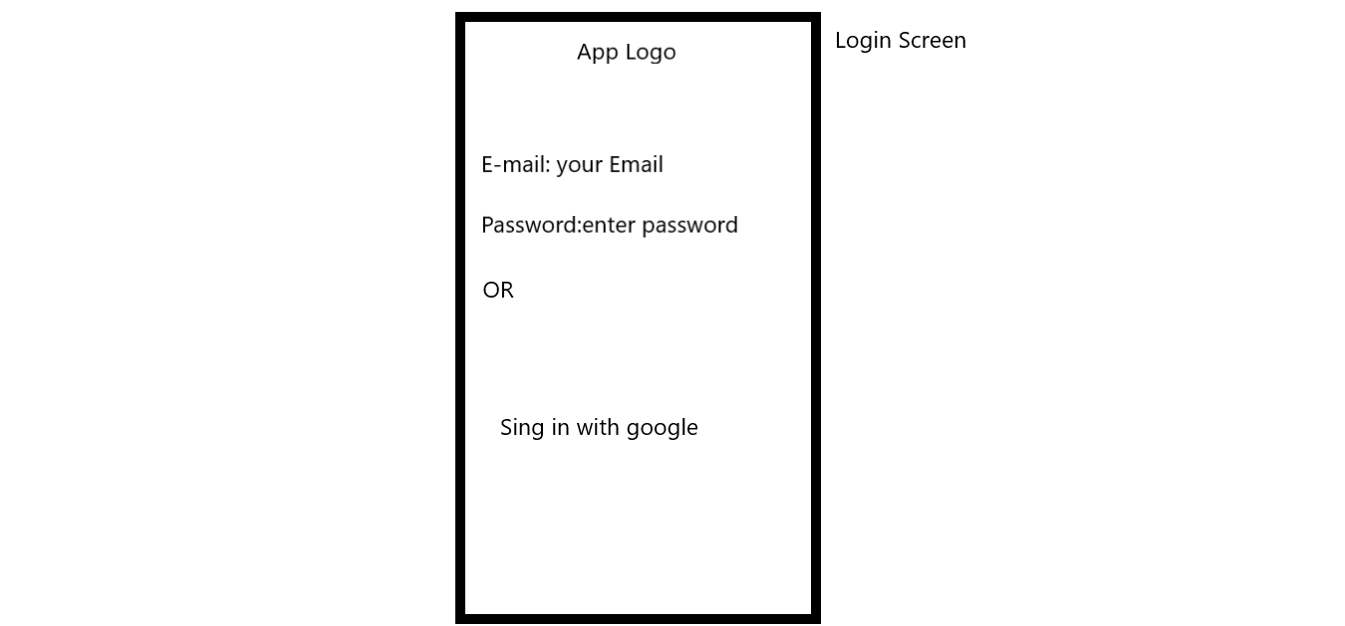

**Calculator Screen: this screen will help you to calcula simple math problem**

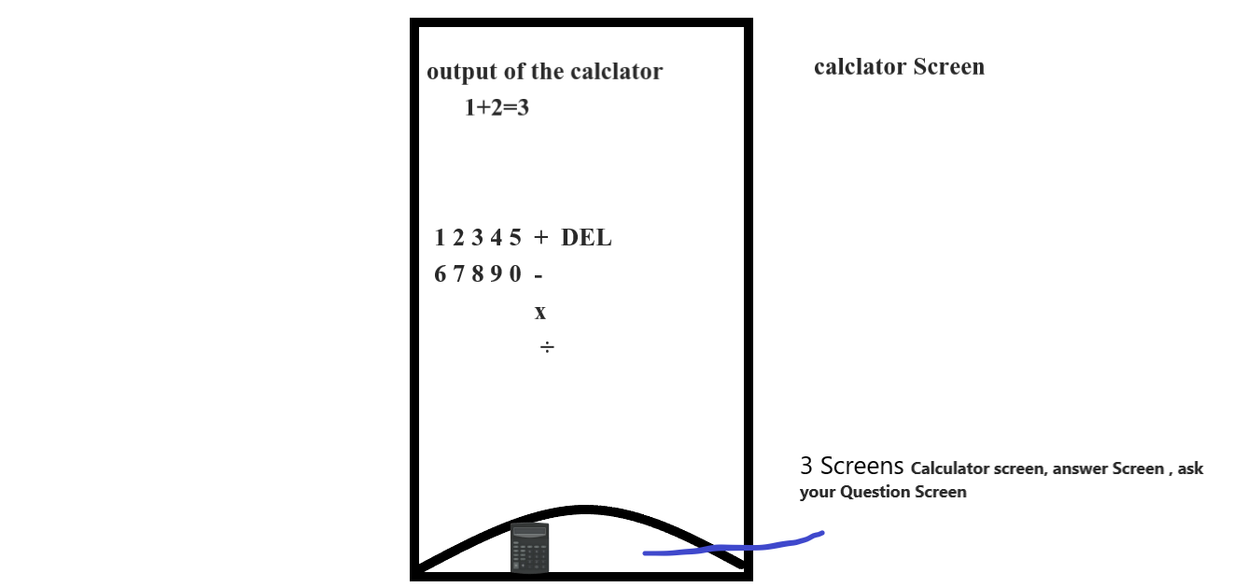

**Ans Screen : here any user can ans anyone other users Question**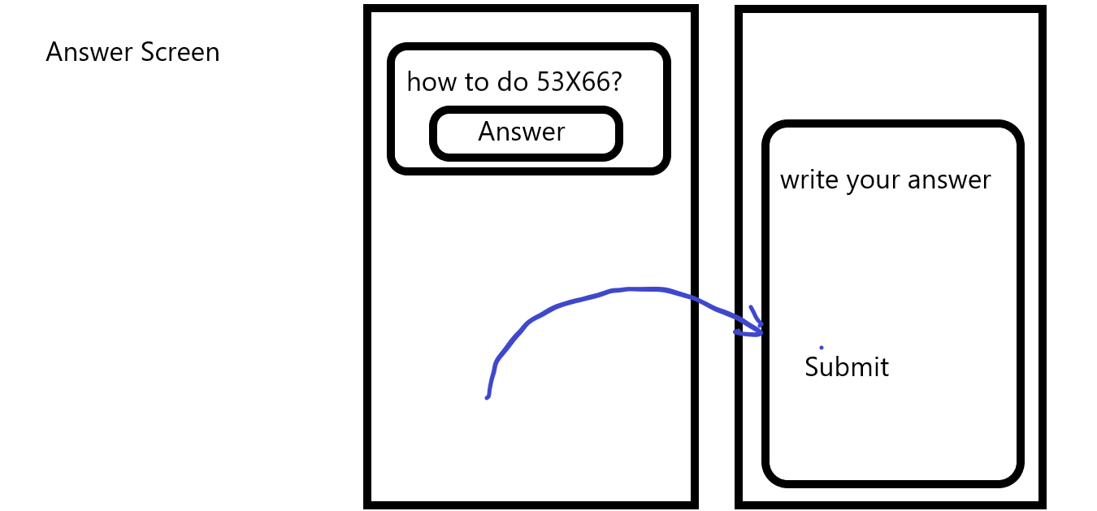

**Ask your Question Screen:there you can type your question and submit it**

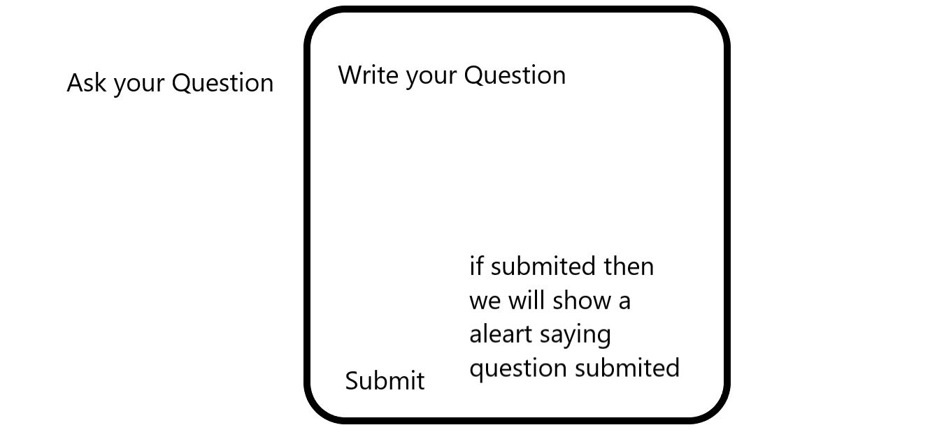

**I will also add a drawer navigator and tab navigator from better look and also use the themes like dark and light**



**Other screens like : profile , logout ,Question**

**Profile** 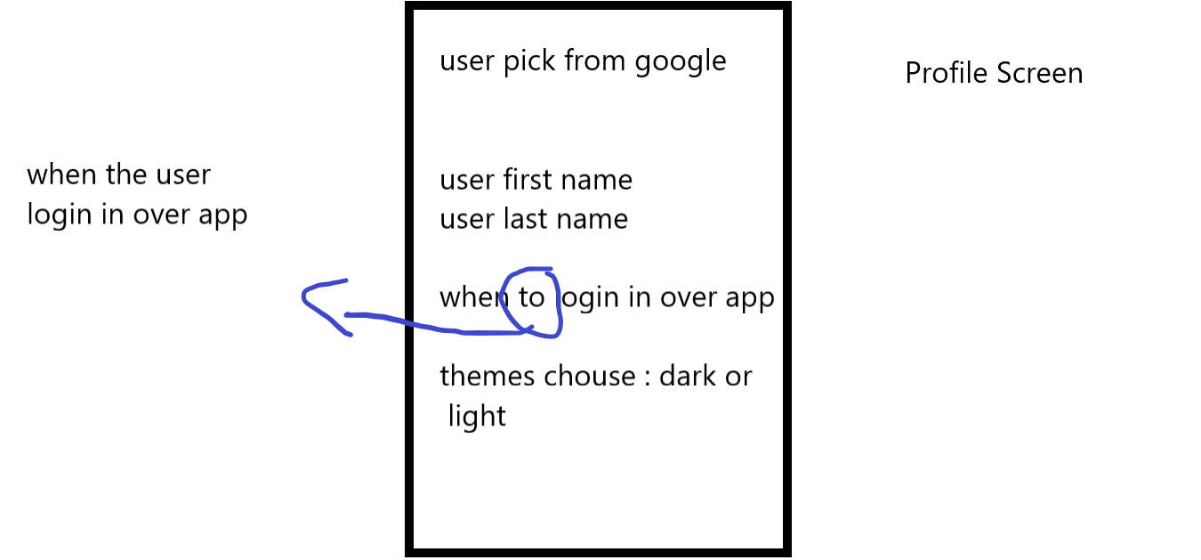

**Logout: simple click on logout and you will logout**

**Question Screen :this is the screen where you can show that how much question did the user ask** 